



International Workshop on
e-Forensics Law

3 LEADING KEYNOTE SPEAKERS

REGISTRATIONS NOW OPEN

Monday January 19 (afternoon), 2009
http://www.e-Forensicslaw.org
National Wine Centre, University of Adelaide, Adelaide, South Australia

The International Workshop on e-Forensics Law will:
- identify international trends in e-Forensics, Digital Evidence and Cyber-Law
- identify the nature of digital evidence and how it is collected in the digital domain
- identify the major challenges in obtaining, marshalling, collating, analysing and presenting digital evidence
- explain how digital evidence is presented in the trial process
- consider whether technology can be trusted for its reliability and neutrality
- consider the role of legal regulation in the digital age

Key topics to be considered in the International Workshop on e-Forensics Law will include issues in the following areas:
- International issues, globalisation and human rights
- Privacy, identity, biometrics and data protection
- Cybercrime, digital crime and high technology crime
- Data-mining and profiling
- e-Discovery
- e-Risk liability, security, regulation and governance
- Virtual worlds and social networks
- Role and function of e-Forensics experts

WORKSHOP CHAIR
Nigel Wilson
Bar Chambers,
Adelaide, South Australia
WORKSHOP PROGRAM COMMITTEE
Robert Chalmers
Adelaide Research and Innovation Pty Ltd, Australia

Jean-Pierre du Plessis
Ferrier Hodgson, Australia
e-FORENSICS 2009
GENERAL CHAIR
Matthew Sorell

University of Adelaide, Australia
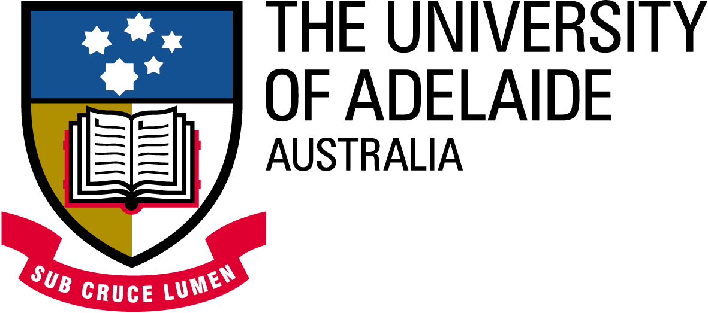

3 PRE-EMINENT KEYNOTE SPEAKERS:
The Cybercrime Convention: a roadmap across jurisdictional nightmares?
Professor Joseph A. Cannataci Spes. Rettsinfo. (Oslo) LLD FBCS CITP

Is Everything Sacred? The Increasing Effect of Privacy and Privilege on eDiscovery and the Changing Role of the Digital Forensics Expert
Dr Glenn S. Dardick

Suspect sciences? Evidentiary problems with emerging technologies
Associate Professor Gary Edmond

The Cybercrime Convention: a roadmap across jurisdictional nightmares?
Professor Joseph A. Cannataci Spes. Rettsinfo. (Oslo) LLD FBCS CITP

ICANN and the World Summits on the Information Society in Geneva or Tunis may have their importance but the Cybercrime Convention is the only binding international treaty governing the Internet. What is it all about and is it going places?

Professor Cannataci is Professor of Law & Director of the Centre for Law, Information & Converging Technologies at the University of Central Lancashire as well as Professor of IT Law at the University of Malta and a UDRP Panelist at the ICANN-accredited Czech Arbitration Court. Previously Chairman of the Committee of Experts on Data Protection at the Council of Europe, he participated in the group drafting the Cybercrime Convention between 1996 and 2000.

Professor Cannataci was decorated by the Republic of France in 2003 when he was elevated to Officier de l’Ordre de Palmes Academiques in recognition of his contribution to academic life and international developments in the field of law and technology. He is currently a member of the Executive of BILETA (British & Irish Law, Education Technology Association) as well as the scientific boards of IT, Media and Economics journals in the UK, Italy, Czech Republic and Romania. He has written over three dozen books and articles on Data Protection Law, Liability for Expert Systems, Legal aspects of medical informatics, copyright in computer software and co-authored various papers and textbook chapters on self-regulation and the Internet, the EU Constitution and data protection, on-line dispute resolution, Data retention and Police data, Internet Governance, data protection and Islam and, most recently, the legal implications of economic growth strategy within the EU.

Is Everything Sacred? The Increasing Effect of Privacy and Privilege on eDiscovery and the Changing Role of the Digital Forensics Expert
Dr Glenn S. Dardick
In an adversarial legal system, the potential for abuse in the discovery process has long been recognized. The potential for abuse exists with those seeking discovery and the rights of those from whom discovery is sought must be protected. In the past discovery could be restricted only with convincing arguments that the information from such discovery might be found unresponsive and consequently certain rights might be abridged. However, it is now with increasing frequency that the claims of Privacy and Privilege are being used to effectively hinder discovery and, in particular, eDiscovery. This has resulted in the substitution of “sparse” data discovery for the full digital forensic images of media. It is under these new circumstances that the role and necessary expertise of digital forensics experts is changing.

Glenn S. Dardick is an Assistant Professor of Information Systems at Longwood University, USA, and is an Adjunct Associate Professor at Edith Cowan University, Australia. He is responsible for the Digital Forensics, Security and Law program at Longwood University and lectures at the undergraduate and postgraduate levels. Glenn S. Dardick also serves as the Editor-in-Chief of the Journal of Digital Forensics, Security and Law and has over 34 years experience in the IT Industry serving in technical, managerial and academic positions in both public organizations and private enterprises. He began working with microcomputers and microcomputer storage media over 30 years ago and was an original member of the IBM PC development team.

Suspect sciences? Evidentiary problems with emerging technologies
Associate Professor Gary Edmond
Many different types of expertise are used in security, surveillance, investigations and the prosecution of crime. In recent years the proliferation of networked computers, mobile phones, and CCTV cameras has fostered new types of evidence and new types of expertise, facilitating the identification of persons from voice recordings, security images, and even the linguistic analysis of SMS and email messages. As things stand, Australian police, investigative and security agencies, prosecutors, along with federal and state courts, have not developed principled approaches to the use and admissibility of emerging technologies, their products and the different forms of expertise (and opinion) based upon them. The paper suggests that these developments are unfortunate because relatively few of the new techniques have been tested or independently reviewed. Using the identification of offenders from security and surveillance images as an example, the paper endeavours to explain some of the problems with pervasive technologies and new forms of expert opinion evidence. In response, it suggests that judges: should show more interest in the reliability (really validity and reliability) of incriminating expert opinion evidence; should abandon recourse to inclusive admissibility criteria (such as the exception to opinion evidence based on ad hoc expertise); should be more willing to apply exclusionary rules and discretions; and should adopt a more credible approach to the practical limitations of adversarial trials and the risks posed by incriminating expert opinion evidence. In closing, it will be suggested that that courts, particularly Australian and British courts, will impose more demanding admissibility standards over the next decade and that those involved in e-forensics, biometrics and identification should begin to respond to anticipated interest in the validity and reliability of their systems and opinions.

Dr Gary Edmond is Associate Professor at the University of New South Wales Law School where he specialises in the study of expert evidence and the relations between law and science. Originally trained in the history and philosophy of science, he subsequently studied law at the Universities of Sydney and Cambridge. An active commentator on expert evidence in Australia, England, the US and Canada, he is a member of the Australasian Academy of Forensic Sciences, the Society for the Social Study of Science (US), and recently served as an international adviser to the Goudge Inquiry into Paediatric Forensic Pathology in Ontario. He is currently involved in a collaborative multidisciplinary project on expert identification evidence with other lawyers, psychologists and forensic scientists as well as an ongoing empirical study of expert evidence in the courts of NSW sponsored by the ARC. Some of his recent publications include: ‘Judging the scientific and medical literature’ (2008) 28 Oxford Journal of Legal Studies 523-561; ‘Specialised knowledge, the exclusionary discretions and reliability’ (2008) 31 UNSW Law Journal 1-55; ‘Secrets of the “hot tub”: Expert witnesses, concurrent evidence and judge-led law reform in Australia’ (2008) 27 Civil Justice Quarterly 51-82.

IMPORTANT DATES:
Workshop Date: January 19, 2009 (afternoon)
The International Workshop on e-Forensics Law is part of the e-Forensics 2009 Conference which will be held from January 19-21, 2009

For more details about the International Workshop please visit http://www.e-forensicslaw.org/

For more details about the e-Forensics 2009 Conference please visit http://www.e-forensics.eu

REGISTRATION DETAILS:
The Registration Package for the International Workshop on e-Forensics Law includes the following items:
- Participation in the Workshop
- Workshop meals (coffee breaks, lunch)
- Banquet at the National Wine Centre on Monday 19 January 2009
- Conference bag and/or conference accessories
- Conference publication (proceedings on CD-ROM)
Members of the constituent organisations of the Law Council of Australia are entitled to a reduced registration fee.
Further discounts also apply for students and early registrations (received by 12 December 2008).

TO REGISTER for the International Workshop please visit the Registration section on the e-Forensics 2009 Conference website at http://www.e-forensics.eu

THE INTERNATIONAL WORKSHOP IS HIGHLY RECOMMENDED FOR:
- Lawyers
- Academics and researchers
- Law enforcement agencies and organizations and regulatory authorities
- Accountants, liquidators and administrators
- Professional advisors

INQUIRIES ABOUT THE INTERNATIONAL WORKSHOP ON E-FORENSICS LAW:
Nigel Wilson, Bar Chambers, 34 Carrington Street Adelaide, South Australia 5000, (ph) (0)8 8205 2966, nigel.wilson@barchambers.com.au

INQUIRIES ABOUT THE E-FORENSICS 2009 CONFERENCE:
Dr Matthew Sorell, School of Electrical and Electronic Engineering, University of Adelaide, South Australia, matthew.sorell@adelaide.edu.au

